Preliminary Capstone Project Recommendations
This capstone course serves as an integrative, high-impact educational experience that challenges students to integrate their accumulated knowledge and apply it to a complex, real-world problem. The capstone projects encourage students to adopt a hands-on approach by building solutions from the ground up rather than relying only on existing tools or templates. The goal is to improve essential skills such as project management, communication, and interdisciplinary analysis, thereby preparing students for professional or academic success. Figure 1 provides a broad overview of how data moves through a system, highlighting the sequential steps of data engineering and the critical underlying disciplines that ensure its success.

Unlike busy work which often involves repetitive, low-cognitive tasks with limited connection to meaningful learning outcomes, the capstone project demands critical thinking, research, and collaboration. Here "reinventing the wheel" is not busy work but a deliberate method for gaining insights, building confidence, and preparing for real-world innovation. Drawing inspiration from Richard Feynman's quote, "What I cannot create, I do not understand", these are some of the great reasons to reinvent the wheel:
- Learn how wheels are made
- Teach others about wheels
- Learn about the inventors of wheels
- Be able to change wheels (or fix) when they break
- Build a better wheel (for some definition of better)
- Help someone in need of a very special wheel (maybe for a wheelchair?)
- Learn a tiny slice of what it means to build a larger system (such as a vehicle)

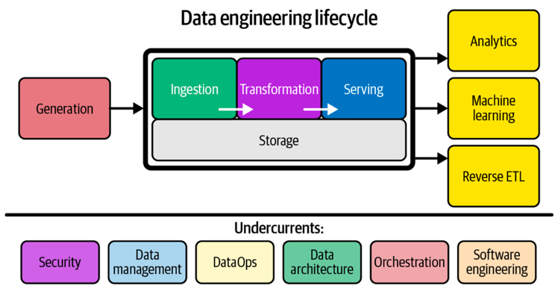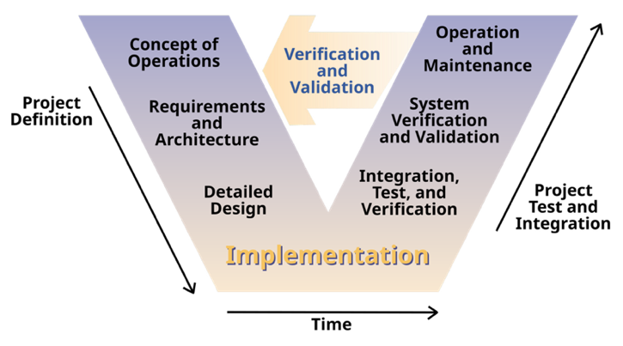
Figure 1 – Components and undercurrents of the data engineering lifecycle. Image extracted from Fundamentals of Data Engineering: Plan and Build Robust Data Systems, J. Reis, M. Housley, 2022. | Figure 2 – Systems Engineering Process. Image extracted from Clarus: Concept of Operations, Federal Highway Administration (FHWA), 2005. (Publication No. FHWA-JPO-05-072.)

V-model
The V-model (Fig. 2) provided a structured framework ideal for guiding the planning and execution of the Data Engineering Capstone Senior Design courses. It led students from defining project goals and requirements through detailed system design and ultimately to implementation. This model encouraged thorough planning, iterative development, and continuous verification, enabling students to grasp the full lifecycle of a data engineering system.
As the capstone transitions into implementation, each phase on the left side of the V-model is mirrored by corresponding testing and validation on the right, ensuring consistent alignment between design intent and delivered outcomes. During the implementation, integration, and verification phases, the principles of the V-model shift from planning into active execution. Each component developed during implementation is constructed according to predefined design specifications and subjected to unit testing to confirm functionality and compliance with requirements. As modules are completed, they move into the integration phase, where subsystems are systematically combined, and integration tests validate their interactions and data flow. This structured approach allows early detection and resolution of defects. Finally, in the verification phase, the complete system is evaluated against the original requirements and acceptance criteria established in the Project Charter, confirming that all functional and performance goals are achieved. This progression reinforces the V-model's emphasis on continuous validation, ensuring that every deliverable aligns with both the design objectives and sponsor expectations.

Project Report and Presentations
The Toaster Project (https://www.thomasthwaites.com/the-toaster-project/) is a conceptual design experiment by British designer Thomas Thwaites (https://en.wikipedia.org/wiki/Thomas_Thwaites_(designer)) in which he set out to make a simple, cheap household toaster from raw materials, by himself, using only basic tools. What he quickly discovered was that even an object that costs only a few dollars in a store depends on an extraordinarily complex system: mining iron ore, refining metals, producing plastics, manufacturing components, logistics, and industrial knowledge that no individual can realistically replicate alone. His final "toaster" barely worked, but the real outcome was the insight into how deeply layered, invisible, and interdependent modern manufacturing truly is.
A capstone is not just about building a product; it is about demonstrating systems thinking, research depth, problem decomposition, experimentation, documentation, and critical reflection.
The Toaster Project embodies all of those:
- It starts with a simple-looking problem and reveals hidden complexity.
- It requires decomposing a system into parts, materials, and processes.
- It forces students to confront real-world constraints, tradeoffs, and failures.
- It culminates in a documented narrative of research, attempts, reflection, and learning—not just a final artifact.
- In short, the Toaster Project provides a powerful model for capstone work because it transforms "build something" into understand, deconstruct, attempt, reflect, and synthesize—which is exactly what a rigorous capstone experience is meant to achieve.

The booklet created by Thomas Thwaites for his project is available here:
https://www.thomasthwaites.com/folio5/wp-content/uploads/2019/07/Toaster_Project-Thomas_Thwaites-Complete.pdf

Project Report and Showcase
The Capstone Report
Listed directions will be given during the semester and on each phase 1-4. Nonetheless each team will create a professional booklet documenting their research, processes, reflections, prototypes, and conclusions. This booklet should be structured like a scholarly narrative with sections for:
- Introduction & Motivation
- Problem Decomposition & Resources Mapping
- Analysis
- Design & Implementation Attempts
- Outcomes, Learnings, and Critical Reflection
- Future Work & Design Implications

The philosophical core remains the same: Take something that appears simple and reconstruct the invisible systems that actually make it work. In data engineering, the “toaster” is not necessarily a physical object, but it is a data product that can seem small on the surface but is, in reality, support by a deep stack of pipelines, infrastructure, governance, and operational complexity. The team mission is to expose and reconstruct the full invisible data supply chain:
raw data → ingestion → storage → transformation → quality → governance → analytics → delivery

Project Presentation (in-class) and Poster (for the Engineering Project Showcases)
April 24th, 2026
https://engineering.tamu.edu/partner-with-us/industry-nonprofit-partnerships/project-showcase/index.html

